CREATIVE ALIBI
Authenticity Companion for Content Creators
Pendamping Autentisitas untuk Kreator Konten
Product Requirements Document (PRD), v4.0
Disusun untuk: AI Builders Challenge, July Theme
"Reimagine Creative Industries with AI"
Bilingual Document, English / Bahasa Indonesia
July 2026

Daftar Isi / Table of Contents
1. Executive Summary / Ringkasan Eksekutif
2. Problem Statement / Pernyataan Masalah
3. Product Vision & Challenge Fit / Visi Produk & Kesesuaian Tema
4. Core Concept & Security Highlight / Konsep Utama & Sorotan Keamanan
5. User Personas / Persona Pengguna
6. User Workflow / Alur Kerja Pengguna
7. System Architecture / Arsitektur Sistem
8. AI Layer, IBM Technology Integration / Layer AI, Integrasi Teknologi IBM
9. System Logic & Data Model / Logika Sistem & Model Data
10. Feature Breakdown / Rincian Fitur
11. Success Metrics / Metrik Keberhasilan
12. Risks & Mitigations / Risiko & Mitigasi
13. Team Structure & Job Descriptions / Struktur Tim & Deskripsi Kerja
14. Hackathon Roadmap & Timeline / Peta Jalan & Linimasa
15. Future Work, Post-Hackathon / Kerja Lanjutan Pasca-Hackathon
16. Conclusion / Kesimpulan

1. Executive Summary
Ringkasan Eksekutif
EN This PRD defines Creative Alibi: Authenticity Companion, a tool that helps genuine content creators document and prove their creative process, protecting them from unjust false-positive AI-detection accusations, without ever certifying AI-generated work as human. The product combines a local Process Ledger (writing behavior capture), an optional and fully disclosed AI Creative Partner for craft assistance, and a Report Generator that produces a transparent Authenticity Report the creator can attach to their published work. This directly answers the “Reimagine Creative Industries with AI” hackathon theme: it empowers creators to work confidently with AI tools while preserving trust in their authorship.
ID PRD ini menjabarkan Creative Alibi: Authenticity Companion, sebuah alat yang membantu kreator konten asli mendokumentasikan dan membuktikan proses kreatif mereka, melindungi mereka dari tuduhan false-positive deteksi AI yang tidak adil, tanpa pernah mensertifikasi karya buatan AI sebagai karya manusia. Produk ini menggabungkan Process Ledger lokal (perekam perilaku menulis), AI Creative Partner opsional yang sepenuhnya transparan untuk bantuan kreatif, dan Report Generator yang menghasilkan Authenticity Report transparan yang bisa dilampirkan kreator pada karya yang dipublikasikan. Ini menjawab langsung tema hackathon “Reimagine Creative Industries with AI”: memberdayakan kreator untuk bekerja dengan percaya diri bersama alat AI, sekaligus menjaga kepercayaan terhadap kepenulisan mereka.

2. Problem Statement
Pernyataan Masalah
EN Public AI-content detectors are increasingly used by platforms, publishers, universities, and clients to screen submitted work, but they are known to produce false positives, wrongly flagging genuine human writing as AI-generated. This damages the credibility and livelihood of honest creators, especially freelance writers, students, and journalists who have no easy way to prove their work was truly their own.
ID Detektor konten AI publik semakin banyak digunakan oleh platform, penerbit, universitas, dan klien untuk menyaring karya yang dikirimkan, namun detektor ini diketahui menghasilkan false-positive, salah menandai tulisan manusia asli sebagai buatan AI. Hal ini merusak kredibilitas dan mata pencaharian kreator jujur, terutama penulis lepas, mahasiswa, dan jurnalis yang tidak punya cara mudah untuk membuktikan karya mereka benar-benar buatan sendiri.
EN At the same time, creative industries are being reshaped by AI tools, writing assistants, brainstorming partners, style suggestions, and creators need a way to use these tools openly and responsibly, without that usage being confused with wholesale AI authorship. What's missing is a trustworthy, verifiable record of how a piece of work was actually made.
ID Di saat yang sama, industri kreatif sedang berubah oleh alat AI, asisten menulis, mitra brainstorming, saran gaya, dan kreator membutuhkan cara untuk memakai alat ini secara terbuka dan bertanggung jawab, tanpa penggunaan itu disalahartikan sebagai karya AI sepenuhnya. Yang hilang adalah catatan yang tepercaya dan dapat diverifikasi tentang bagaimana sebuah karya benar-benar dibuat.

3. Product Vision & Challenge Fit
Visi Produk & Kesesuaian Tema

Vision / Visi
EN Creative Alibi becomes the trust layer of the creative process, a companion that stands beside every writer, not to fool detectors, but to make their real effort visible, defensible, and portable across platforms, submissions, and clients.
ID Creative Alibi menjadi lapisan kepercayaan dari proses kreatif, pendamping yang berdiri di sisi setiap penulis, bukan untuk mengelabui detektor, melainkan membuat usaha nyata mereka terlihat, dapat dipertahankan, dan portabel lintas platform, submission, dan klien.

Alignment with “Reimagine Creative Industries with AI” / Kesesuaian dengan Tema
Theme Signal (Official Examples) | Creative Alibi Feature
Personalized creative assistants | AI Creative Partner: disclosed, on-demand style & brainstorming suggestions
Storytelling & content creation tools | Process Ledger visualized as a personal “Creative Timeline”
Helping creators work smarter, not harder | Authenticity Report removes the anxiety and repeated re-submission cycles caused by false AI flags
Real-world impact for creative professionals | Directly protects income & credibility of freelancers, students, journalists

4. Core Concept & Security Highlight
Konsep Utama & Sorotan Keamanan
★ HIGHLIGHT, The Process Ledger is the absolute foundation of eligibility
Eligibility for an Authenticity Report is entirely dependent on the writer's own process metadata, typing cadence, natural pauses, revision patterns, and copy-paste ratio, captured locally while the work is written. This is the system's non-negotiable security core. The AI Creative Partner is only ever a disclosed assistance layer that helps a writer refine their own 100%-authored work; it is never a mechanism to launder or relabel AI-generated content as human. If the process metadata does not reflect genuine authorship, no report is issued, regardless of how the final text reads.
SOROTAN, Process Ledger adalah fondasi mutlak kelayakan
Kelayakan Authenticity Report sepenuhnya bergantung pada metadata proses milik penulis sendiri, ritme mengetik, jeda alami, pola revisi, dan rasio copy-paste, yang direkam secara lokal selama karya ditulis. Inilah inti keamanan sistem yang mutlak dan tidak bisa ditawar. AI Creative Partner hanya berfungsi sebagai lapisan bantuan yang transparan untuk menyempurnakan karya yang 100% ditulis sendiri oleh penulis; ini bukan mekanisme untuk mencuci atau melabeli ulang konten buatan AI sebagai karya manusia. Jika metadata proses tidak mencerminkan kepenulisan yang sah, laporan tidak akan diterbitkan, berapa pun bagusnya teks akhirnya terbaca.
Why this design is honest, not just strict / Mengapa desain ini jujur, bukan sekadar ketat
EN Unlike a detector-evasion loop, this system makes no claim to be “AI-proof.” It claims only what it can actually verify: that a specific process of writing took place, with specific characteristics, at a specific time. That claim is auditable and defensible, which is exactly what gives it credibility with platforms, publishers, and institutions.
ID Berbeda dengan loop pengelabuan detektor, sistem ini tidak mengklaim “anti-AI”. Sistem hanya mengklaim apa yang benar-benar bisa diverifikasi: bahwa sebuah proses menulis tertentu telah terjadi, dengan karakteristik tertentu, pada waktu tertentu. Klaim ini dapat diaudit dan dipertahankan, dan justru itulah yang memberi kredibilitas di mata platform, penerbit, dan institusi.

5. User Personas
Persona Pengguna
Persona | Need / Kebutuhan | How Creative Alibi Helps
Freelance Writer (Penulis Lepas) | Protect income from unjust AI-flag rejections | Attaches Authenticity Report to every client submission
University Student (Mahasiswa) | Avoid academic integrity false accusations | Report as supporting evidence alongside coursework
Journalist / Blogger (Jurnalis/Blogger) | Preserve credibility with editors & readers | Public-facing “verified process” badge on published pieces
Content Creator using AI tools (Kreator yang pakai AI) | Use AI assistance openly without being penalized unfairly | Transparent AI-assist logging distinguishes assistance from authorship

6. User Workflow
Alur Kerja Pengguna
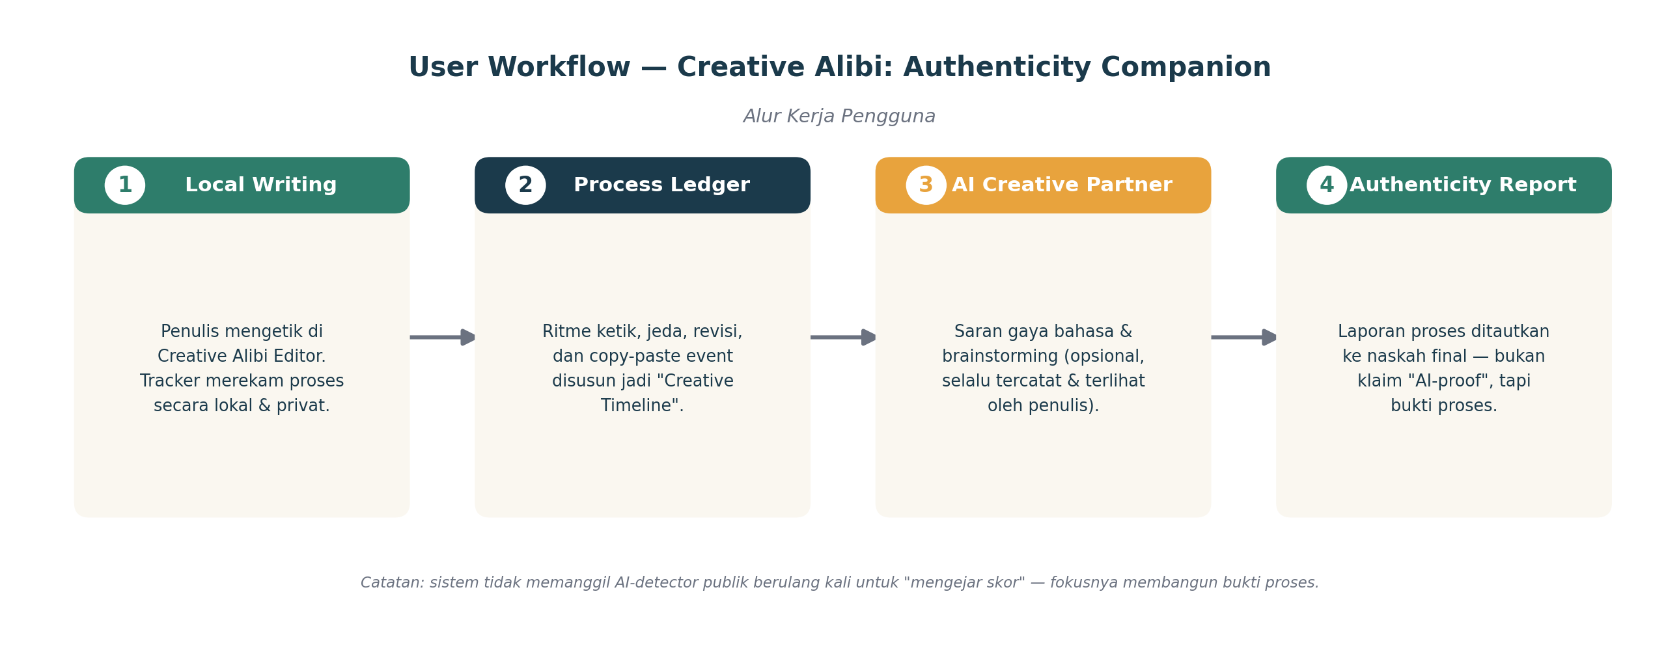
Figure 1. End-to-end user workflow, from local writing to the final Authenticity Report.
Gambar 1. Alur kerja pengguna dari menulis lokal hingga Authenticity Report akhir.
Phase 1, Local Writing / Fase 1, Menulis Lokal
EN The writer works inside the Creative Alibi editor. The Behavioral Tracker Module records keystrokes, pauses, and paste events locally and privately, nothing leaves the device at this stage.
ID Penulis bekerja di dalam editor Creative Alibi. Behavioral Tracker Module merekam ketikan, jeda, dan peristiwa paste secara lokal dan privat, tidak ada data yang keluar dari perangkat pada tahap ini.
Phase 2, Process Ledger Built / Fase 2, Process Ledger Dibangun
EN Raw behavioral data is structured into a “Creative Timeline”: cadence score, revision map, and copy-paste ratio, visible to the writer as they work.
ID Data perilaku mentah disusun menjadi “Creative Timeline”: skor ritme, peta revisi, dan rasio copy-paste, terlihat oleh penulis selagi mereka bekerja.
Phase 3, AI Creative Partner (optional) / Fase 3, AI Creative Partner (opsional)
EN If the writer chooses, they can request style suggestions or brainstorming help. Every suggestion is timestamped and tagged as AI-assisted, never silently merged into the “human-typed” record.
ID Jika penulis memilih, mereka bisa meminta saran gaya atau bantuan brainstorming. Setiap saran diberi cap waktu dan ditandai sebagai AI-assisted, tidak pernah digabungkan diam-diam ke catatan “ketikan manusia”.
Phase 4, Authenticity Report / Fase 4, Authenticity Report
EN The system compiles the Creative Timeline and any AI-assist log into a shareable Authenticity Report, which the writer attaches to their submission as supporting evidence.
ID Sistem menyusun Creative Timeline dan log AI-assist (bila ada) menjadi Authenticity Report yang bisa dibagikan, yang dilampirkan penulis pada submission sebagai bukti pendukung.

7. System Architecture
Arsitektur Sistem
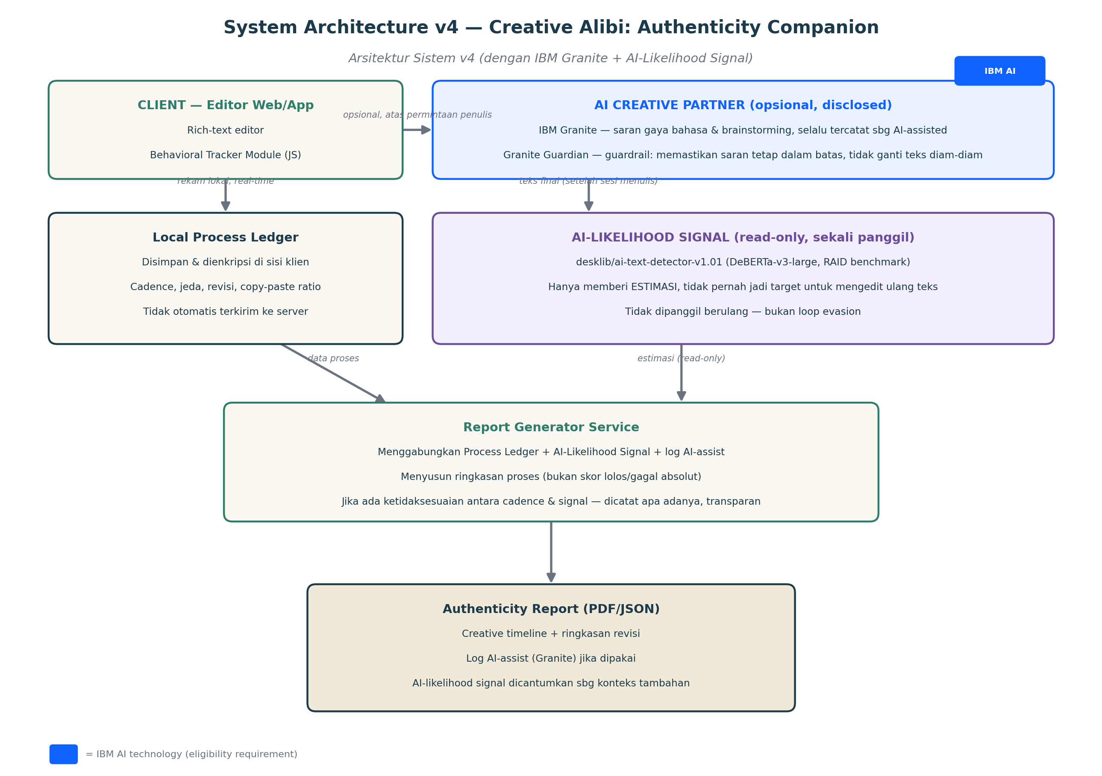
Figure 2. System architecture v4, including the IBM Granite AI Creative Partner layer and the read-only AI-Likelihood Signal layer.
Gambar 2. Arsitektur sistem v4, termasuk layer AI Creative Partner berbasis IBM Granite dan layer AI-Likelihood Signal yang bersifat read-only.
Component | Responsibility | Notes
Client Editor | Rich-text writing surface + Behavioral Tracker Module | Runs in browser/app; captures raw signals
Local Process Ledger | Encrypted local store of writing behavior | Not auto-uploaded; writer controls sharing
AI Creative Partner (IBM Granite) | Optional style/brainstorm suggestions | Every call logged as AI-assist, never silent; satisfies IBM tech requirement
AI-Likelihood Signal (desklib detector) | One-shot, read-only AI-probability estimate | Never re-called in a loop; informational only
Report Generator Service | Builds the human-readable Authenticity Report | Combines process data + signal; does not chase a detector score

8. AI Layer, IBM Technology Integration
Layer AI, Integrasi Teknologi IBM
EN Creative Alibi uses two distinct AI layers, each with a clearly bounded role. This separation is deliberate: the generative layer helps the writer, while the detection layer only informs the report, it never edits, and it never loops.
ID Creative Alibi menggunakan dua layer AI yang berbeda, masing-masing dengan peran yang dibatasi secara jelas. Pemisahan ini disengaja: layer generatif membantu penulis, sementara layer deteksi hanya memberi informasi untuk laporan, tidak pernah mengedit, dan tidak pernah berulang (loop).

8.1 Generative Layer, IBM Granite (AI Creative Partner)
EN IBM Granite (Granite 4.1 family, e.g. the 3B or 8B instruct variant for hackathon-friendly latency) powers the AI Creative Partner: on-demand style suggestions, brainstorming, and light editing help. Granite is a decoder-only generative foundation model built for exactly these tasks, content generation, summarization, and classification, and is available through watsonx.ai and Hugging Face, satisfying the Challenge's IBM AI-technology requirement.
ID IBM Granite (keluarga Granite 4.1, misalnya varian instruct 3B atau 8B untuk latensi yang ramah hackathon) menjadi mesin di balik AI Creative Partner: saran gaya bahasa, brainstorming, dan bantuan penyuntingan ringan, sesuai permintaan. Granite adalah model fondasi generatif decoder-only yang memang dibangun untuk tugas semacam ini, content generation, summarization, classification, dan tersedia lewat watsonx.ai maupun Hugging Face, sehingga memenuhi syarat teknologi IBM dari Challenge.
EN Granite Guardian is layered on top as a guardrail: it monitors the Creative Partner's own outputs to ensure suggestions stay within scope (style/brainstorm help) and are never silently merged into the writer's tracked text without disclosure.
ID Granite Guardian dipasang sebagai lapisan pengaman: memantau output AI Creative Partner sendiri untuk memastikan saran tetap dalam cakupan (bantuan gaya/brainstorming) dan tidak pernah digabungkan diam-diam ke teks yang dilacak milik penulis tanpa keterbukaan.

8.2 Detection Layer, AI-Likelihood Signal (informational only)
★ HIGHLIGHT, This layer informs the report, it does not gatekeep or get defeated
desklib/ai-text-detector-v1.01 (a DeBERTa-v3-large fine-tune, a leading model on the RAID benchmark) is called exactly once, after the writing session ends, purely to produce an AI-likelihood estimate that is printed transparently into the Authenticity Report alongside the Process Ledger evidence. It is never called in a loop, and the text is never rewritten to lower its score, doing so would recreate the exact evasion risk this product was redesigned to avoid. If the signal and the process metadata disagree (e.g. high cadence score but high AI-likelihood), the report states that discrepancy plainly rather than hiding or resolving it.
SOROTAN, Layer ini memberi informasi untuk laporan, bukan menjadi gerbang atau target untuk dikalahkan
desklib/ai-text-detector-v1.01 (hasil fine-tune dari DeBERTa-v3-large, salah satu model terdepan di RAID benchmark) dipanggil tepat satu kali, setelah sesi menulis selesai, semata-mata untuk menghasilkan estimasi kemungkinan-AI yang dicantumkan secara transparan di Authenticity Report berdampingan dengan bukti dari Process Ledger. Model ini tidak pernah dipanggil dalam loop, dan teks tidak pernah ditulis ulang untuk menurunkan skornya, melakukan itu akan menghidupkan kembali risiko evasion yang justru menjadi alasan produk ini dirancang ulang. Jika sinyal ini dan metadata proses tidak sejalan (misalnya skor ritme tinggi tapi AI-likelihood juga tinggi), laporan menyatakan ketidaksesuaian itu apa adanya, bukan menyembunyikan atau menyelaraskannya.

8.3 Why two separate layers, not one
Layer | Technology | Role | Called
Generative | IBM Granite + Granite Guardian | Helps the writer, on request, fully disclosed | On-demand, multiple times per session
Detection | desklib/ai-text-detector-v1.01 | Informs the report only, never edits text | Once, after the session ends
EN Keeping these layers separate is itself a safeguard: the model that helps the writer create is never the same model, or process, used to score them, which removes any incentive to design around a shared feedback loop.
ID Memisahkan kedua layer ini adalah bentuk pengaman itu sendiri: model yang membantu penulis berkarya tidak pernah menjadi model, atau proses, yang sama dengan yang menilai mereka, sehingga menghilangkan insentif untuk merancang cara mengakali sebuah loop umpan-balik bersama.

9. System Logic & Data Model
Logika Sistem & Model Data
EN The pseudocode below reflects the revised logic: no external AI-detector calls, no paraphrase-to-evade loop. The system only validates and summarizes the writer's own process data.
ID Pseudo-code di bawah ini mencerminkan logika yang telah direvisi: tidak ada panggilan ke detektor AI eksternal, tidak ada loop parafrase-untuk-mengelabui. Sistem hanya memvalidasi dan meringkas data proses milik penulis sendiri.
// 1. Data Structure Definitions
interface ProcessLedger {
typingCadenceScore: number; // 0-100, natural typing rhythm
pauseProfile: number[]; // distribution of natural pauses
copyPasteRatio: number; // % of text that was pasted
revisionCount: number; // number of meaningful edits
timeSpentSeconds: number;
aiAssistLog: AIAssistEvent[]; // disclosed AI Creative Partner usage
}

interface AIAssistEvent {
timestamp: string;
type: 'style_suggestion' | 'brainstorm' | 'grammar_check';
accepted: boolean; // did the writer keep the suggestion?
}

// 2. Main Workflow, no detector-evasion loop
async function generateAuthenticityReport(ledger: ProcessLedger) {
const isGenuineProcess = validateProcessLedger(ledger);

if (!isGenuineProcess) {
return {
status: 'NOT_ELIGIBLE',
reason: 'Process metadata does not reflect a genuine',
'authorship pattern (e.g. excessive pasted content).'
};
}

return {
status: 'ISSUED',
report: buildReport(ledger) // timeline + disclosed AI-assist log
};
}

// 3. Process Validation, same rigor, honest purpose
function validateProcessLedger(ledger: ProcessLedger) {
const MIN_TYPING_SCORE = 75;
const MAX_COPY_PASTE_RATIO = 0.20;

if (ledger.copyPasteRatio > MAX_COPY_PASTE_RATIO) return false;
if (ledger.typingCadenceScore < MIN_TYPING_SCORE) return false;
return true;
}

10. Feature Breakdown
Rincian Fitur
Feature | Description (EN) | Deskripsi (ID) | Priority
Behavioral Tracker Module | Local keystroke/pause/paste capture in the editor | Perekam ketikan/jeda/paste lokal di editor | P0
Creative Timeline View | Visual playback of the writing process for the writer | Tampilan visual proses menulis untuk penulis | P0
AI Creative Partner | Disclosed style & brainstorm suggestions | Saran gaya & brainstorming yang transparan | P1
Authenticity Report Export | PDF/JSON report attachable to submissions | Laporan PDF/JSON untuk dilampirkan ke submission | P0
Verified Process Badge | Shareable badge/link for published work | Badge/tautan untuk karya yang dipublikasikan | P2

11. Success Metrics
Metrik Keberhasilan
Metric | Target (Hackathon MVP)
Reports generated in demo | ≥ 3 complete end-to-end reports
False-positive scenarios addressed | At least 1 realistic before/after case in the demo video
Tracker accuracy (manual QA) | Cadence & paste detection consistent across 10 test runs
Judge-facing clarity | Non-technical judge can explain the product back in 1 sentence

12. Risks & Mitigations
Risiko & Mitigasi
Risk / Risiko | Mitigation / Mitigasi
Tracker can still be gamed by very patient bad actors | Positioned as supporting evidence, not an absolute guarantee, report is transparent about its own limits
Privacy concerns over keystroke logging | All raw data stays local by default; only the summarized report is shareable, writer controls export
Judges may confuse this with the old evasion concept | Demo video explicitly contrasts old vs. new approach in the first 20 seconds
Short hackathon timeline | MVP scoped to P0 features only; AI Creative Partner uses a lightweight prompt-based integration
Detection layer (desklib) misread as a pass/fail gate | UI and report copy explicitly label it “estimate, not a verdict”; eligibility still runs only on Process Ledger validation
Detection layer re-purposed into an evasion loop later on | Architecturally called once, read-only, with no code path that feeds its output back into text generation

13. Team Structure & Job Descriptions
Struktur Tim & Deskripsi Kerja
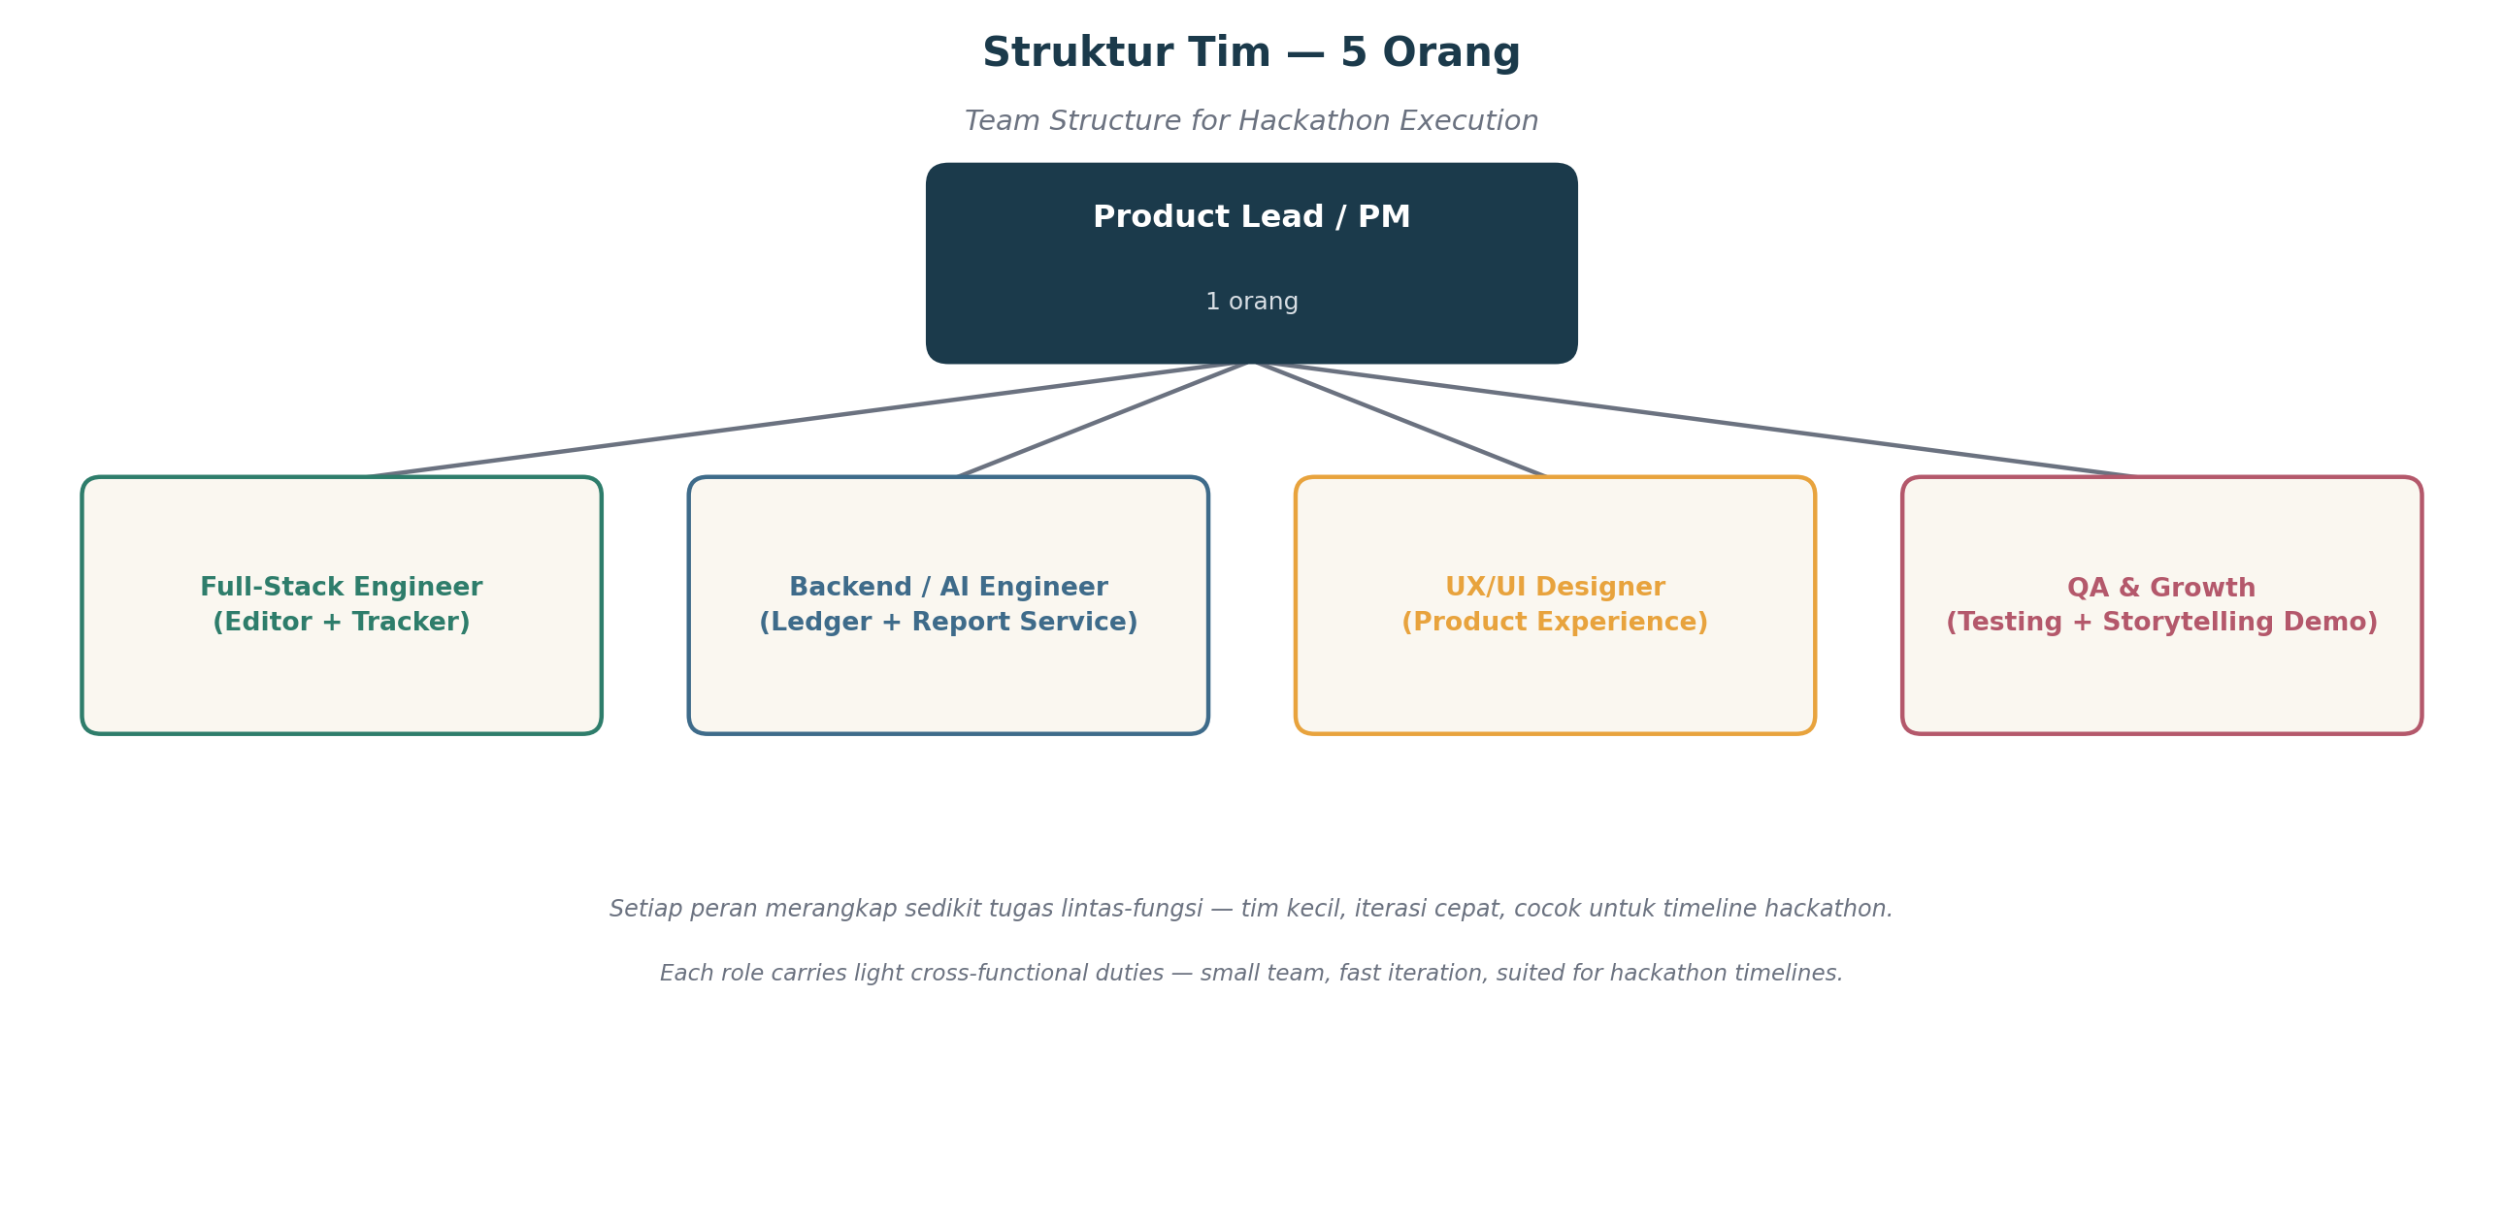
Figure 3. Team structure for a 5-person hackathon team.
Gambar 3. Struktur tim untuk tim hackathon beranggotakan 5 orang.

1. Product Lead / Project Manager
Ketua Produk / Manajer Proyek
Responsibilities / Tanggung Jawab:
- Own the product narrative and ensure it stays aligned with the “Reimagine Creative Industries with AI” theme
- Coordinate timeline, task breakdown, and daily syncs across the 5-person team
- Write and rehearse the final demo/pitch script (3-minute video)
- Liaise with hackathon organizers and manage submission requirements
- Memegang narasi produk dan memastikan tetap selaras dengan tema “Reimagine Creative Industries with AI”
- Mengoordinasikan linimasa, pembagian tugas, dan sinkronisasi harian tim
- Menulis dan melatih skrip demo/pitch akhir (video 3 menit)
- Berkomunikasi dengan panitia hackathon dan mengelola kelengkapan submission
Key Skills: Project management, storytelling, stakeholder communication

2. Full-Stack Engineer (Editor + Tracker)
Full-Stack Engineer (Editor + Tracker)
Responsibilities / Tanggung Jawab:
- Build the writing editor UI and integrate the Behavioral Tracker Module (keystroke, pause, paste capture)
- Implement the Creative Timeline visualization
- Ensure local-first data handling and basic encryption for the Process Ledger
- Membangun UI editor menulis dan mengintegrasikan Behavioral Tracker Module (perekam ketikan, jeda, paste)
- Mengimplementasikan visualisasi Creative Timeline
- Memastikan penanganan data local-first dan enkripsi dasar untuk Process Ledger
Key Skills: JavaScript/TypeScript, React, browser event handling, front-end state management

3. Backend / AI Engineer
Backend / AI Engineer
Responsibilities / Tanggung Jawab:
- Build the Report Generator Service that summarizes Process Ledger data into the Authenticity Report
- Integrate IBM Granite (via watsonx.ai or Hugging Face) as the AI Creative Partner engine, with Granite Guardian as an output guardrail
- Integrate desklib/ai-text-detector-v1.01 as a one-shot, read-only AI-likelihood signal, never call it in a loop
- Implement the process-validation logic (cadence & paste-ratio thresholds)
- Membangun Report Generator Service yang meringkas data Process Ledger menjadi Authenticity Report
- Mengintegrasikan IBM Granite (lewat watsonx.ai atau Hugging Face) sebagai mesin AI Creative Partner, dengan Granite Guardian sebagai guardrail output
- Mengintegrasikan desklib/ai-text-detector-v1.01 sebagai sinyal AI-likelihood read-only yang dipanggil sekali, tidak pernah dalam loop
- Mengimplementasikan logika validasi proses (ambang ritme & rasio paste)
Key Skills: Node.js/Python backend, REST API design, IBM watsonx.ai / Granite integration, Hugging Face inference, data modeling

4. UX/UI Designer
UX/UI Designer
Responsibilities / Tanggung Jawab:
- Design the editor experience, Creative Timeline visualization, and Authenticity Report layout
- Ensure the product visually communicates “transparency” and “trust,” not “enforcement” or “policing”
- Design the Verified Process Badge and shareable report format
- Merancang pengalaman editor, visualisasi Creative Timeline, dan tata letak Authenticity Report
- Memastikan produk secara visual mengomunikasikan “transparansi” dan “kepercayaan”, bukan “penegakan” atau “pengawasan”
- Merancang Verified Process Badge dan format laporan yang dapat dibagikan
Key Skills: Figma, interaction design, visual storytelling, accessibility

5. QA & Growth (Demo Storytelling)
QA & Growth (Storytelling Demo)
Responsibilities / Tanggung Jawab:
- Test the tracker and report generation across realistic writing scenarios
- Prepare the before/after false-positive case study used in the demo
- Support video production, pitch deck, and submission materials (GitHub repo readme, screenshots)
- Menguji tracker dan pembuatan laporan pada berbagai skenario menulis yang realistis
- Menyiapkan studi kasus before/after false-positive yang dipakai dalam demo
- Mendukung produksi video, pitch deck, dan materi submission (readme repo GitHub, tangkapan layar)
Key Skills: Manual QA, content writing, video editing basics, presentation design

14. Hackathon Roadmap & Timeline
Peta Jalan & Linimasa
Week / Minggu | Focus (EN) | Fokus (ID)
Week 1 | Finalize PRD, wireframes, and architecture; set up repo, watsonx.ai/Granite access, and environments | Finalisasi PRD, wireframe, dan arsitektur; setup repo, akses watsonx.ai/Granite, dan environment
Week 2 | Build editor + Behavioral Tracker Module; start Report Generator | Membangun editor + Behavioral Tracker Module; mulai Report Generator
Week 3 | Integrate IBM Granite (+ Granite Guardian) and desklib AI-likelihood signal; build Authenticity Report export; QA pass 1 | Integrasi IBM Granite (+ Granite Guardian) dan sinyal AI-likelihood desklib; buat ekspor Authenticity Report; QA tahap 1
Week 4 | Polish UI, record demo video, finalize submission (repo, readme, pitch) | Poles UI, rekam video demo, finalisasi submission (repo, readme, pitch)

15. Future Work, Post-Hackathon
Kerja Lanjutan Pasca-Hackathon
EN Beyond the hackathon MVP, the AI-likelihood signal could evolve from a ready-made model into an in-house classifier trained specifically for creative-writing contexts, improving relevance beyond generic AI-detection benchmarks.
ID Di luar MVP hackathon, sinyal AI-likelihood bisa berkembang dari model siap pakai menjadi classifier in-house yang dilatih khusus untuk konteks tulisan kreatif, sehingga relevansinya melampaui benchmark deteksi-AI generik.
- Fine-tune a base model (roberta-base or microsoft/deberta-v3-large) on creative-writing-specific data, rather than relying solely on a general-purpose detector.
- Use Rajarshi-Roy-research/Defactify_Text_Dataset and Hello-SimpleAI/HC3 as benchmark/validation sets when evaluating any in-house model.
- Validate any custom model against the RAID benchmark before considering it a replacement for the desklib signal.
- Fine-tune model dasar (roberta-base atau microsoft/deberta-v3-large) dengan data khusus tulisan kreatif, bukan sekadar mengandalkan detektor generik.
- Gunakan Rajarshi-Roy-research/Defactify_Text_Dataset dan Hello-SimpleAI/HC3 sebagai data benchmark/validasi saat mengevaluasi model in-house.
- Validasi model custom apa pun terhadap RAID benchmark sebelum dianggap layak menggantikan sinyal desklib.

16. Conclusion
Kesimpulan
EN Creative Alibi: Authenticity Companion reframes the original protection goal around honest, verifiable evidence rather than detector evasion. It gives genuine creators a defensible record of their process, welcomes responsible AI assistance through full disclosure, and directly serves the “Reimagine Creative Industries with AI” theme by helping creators work confidently alongside AI, without ever letting AI-generated work pass as human. This is a product a 5-person team can build, demo, and stand behind with a clear conscience.
ID Creative Alibi: Authenticity Companion membingkai ulang tujuan perlindungan awal di sekitar bukti yang jujur dan dapat diverifikasi, alih-alih mengelabui detektor. Produk ini memberi kreator asli catatan proses yang dapat dipertahankan, menyambut bantuan AI yang bertanggung jawab melalui keterbukaan penuh, dan langsung melayani tema “Reimagine Creative Industries with AI” dengan membantu kreator bekerja percaya diri bersama AI, tanpa pernah membiarkan karya buatan AI lolos sebagai karya manusia. Ini adalah produk yang bisa dibangun, didemokan, dan dipertanggungjawabkan dengan hati nurani yang bersih oleh tim beranggotakan 5 orang.

